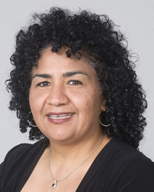Maricela Obiedo
Receptionist & Secretary
Maricela and her husband Ermilo came to Webb Chapel in 2005. After studying with Henry, they both were baptized into Christ on January 22, 2006. Both Ermilo and Maricela immediately became very active with the Hispanic members. They are the parents of Anthony and Rebecca. Both Maricela and Ermilo are native Texans. They met when she was a receptionist at a radio station where Ermilo worked. Ermilo continues to work in radio and helps with Our Planet Live.
Maricela serves as Receptionist. She is fluent in both Spanish and English.

